Committee Secretary
Senate Legal and Constitutional Affairs Committee
PO Box 6100
Parliament House
Canberra ACT 2600

Inquiry into Australia’s youth justice and incarceration system
The Ngaanyatjarra Pitjantjatjara Yankunytjatjara Women’s Council (‘NPYWC’) writes a submission for the Inquiry into Australia’s youth justice and incarceration system.

Who are we?
Ngaanyatjarra Pitjantjatjara Yankunytjatjara Women’s Council (NPYWC) is a member-led, Aboriginal Community Controlled Organisation (ACCO), governed and directed by Ngaanyatjarra Pitjantjatjara Yankunytjatjara (NPY) women from 26 remote desert communities across the cross-border regions of Western Australia, South Australia, and the Northern Territory — an area covering over 350,000 square kilometres and a population of approximately 6,000 Anangu. Guided by women’s law, authority, and culture, NPYWC delivers a wide range of health, social, and cultural services, and social enterprise opportunities, that promote safety, wellbeing, and empowerment for Anangu women, children, and families in the NPY Lands. Annexed and labelled “A” is a map of the region.
NPYWC holds a deep legacy for the advocacy of human rights for women and children. Embedded in NPYWC’s history is the gathering and strategic organisation of Anangu women who wanted to be seen and heard during the Pitjantjatjara Land Rights movement. Annexed and labelled “B” is a painting by Mantatjara Wilson (deceased) that tells the story of the time Anangu women came together to form their own Women’s Council.

NPYWC has long offered safe and culturally relevant support and services that sustain the development of children, young people, their families and communities. This is part of the individual and collective strategy for supporting young people in the NPY region. NPYWC provides a wrap-around service model that centres lived experience, advocacy, collaboration, education and leadership. Fostering all of these streams allows for children and young people to speak up about issues most affecting them whilst also providing a two-way learning opportunity for engagement and service provision.

NPYWC’s theory of change and service provision is rooted in strengths-based practices and localised processes. In essence – Anangu youth are best placed to determine what is best for Anangu youth. This is the catalyst for transforming communities with the intention of every person fulfilling their right to full emotional, social, physical and spiritual wellbeing.

“I believe it's essential for young people to stay connected to their culture and Anangu ways, and that Elders should play a role in guiding them […] support programs like youth initiatives can help distract them from negative influences.” – Young Person, Pukatja
Our Submission to the inquiry into Australia’s youth justice and incarceration system
NPYWC strongly condemns the rise of punitive youth justice policies across Australia and the growing reliance on an un-evidenced “tough on crime” approach for children and young people. We are particularly concerned about the minimum age of criminal responsibility across the NT, SA and WA. For example, despite the United Nations (UN) Committee on the Rights of the Child recommending a minimum age of at least 14 years, the NT’s Country Liberal Party (CLP) Government, upon election, prioritised lowering the age of criminal responsibility from 12 to 10 years of age. SA and WA have similarly disregarded the UN Committee’s advice by failing to raise their minimum age from 10 to 14.
This submission speaks to our concerns regarding:
- Failure to meet international human rights obligations
- Lack of compliance with basic human rights
- The over incarceration of First Nations children
- The impacts of detention on children and young people
- The removal of children and young people from Country and community
- Recommendations – A path forward for Anangu children and young people
Failure to meet international human rights obligations
“At ten- we don’t understand crime.” – Young person, Imanpa.
NPYWC is deeply concerned about the broader youth justice landscape across the NT, SA and WA, particularly the recent changes implemented by the NT Government. Over the past year, the NT Government has introduced harsher bail laws for children and young people whilst removing the legislative principle that states detention should only be used as a last resort. Additionally, significant changes to the NT Youth Justice Act were introduced in 2025, including an expanded use of force within detention facilities, the reintroduction of spit hoods, mechanical restraints, the use of dogs and new provisions around separation which will likely result in prolonged or unjustified isolation. These practices are harmful, dehumanising and constitute clear breaches of Australia’s international human rights obligations, notably the United Nations Declaration on the Rights of Indigenous Peoples (2007), United Nations Convention on the Rights of the Child (1989) and the Convention Against Torture & Other Cruel, Inhuman or Degrading Treatment or Punishment (1984). Recently, the United Nations Working Group on Arbitrary Detention was denied access to all government-run facilities in the NT while attempting to assess Australia's compliance with international standards on the "deprivation of liberty". These measures amount to "serious violations of human rights ... especially in relation to Aboriginal people and the criminal justice system." Aboriginal leaders and human rights advocates across Australia share these concerns, reflected in a formal complaint submitted to the UN Committee on the Elimination of Racial Discrimination by Associate Professor Hannah McGlade, supported by the Human Rights Law Centre.
At present, NPYWC’s Youth Service fills a crucial gap in after school care programs that are non-existent across NPY communities. However, due to staff turnover and inconsistencies in funded programs, young people often miss out on this engagement and support from youth workers and therefore face barriers in accessing better life opportunities. Although more generally, the Australian Government supports families to source educational and care related opportunities near to their place of residence, which is the case in the APY lands (SA), there are a significant number of communities who miss out on this fundamental support in the NT and WA. Of particular concern is the lack of support in the Ngaanyatjarra Lands (WA) where young people are being failed in their early years. In line with research by Professor Kerry Arabeena, NPYWC is aware that the first 1000 days of development in a child’s life are essential for their development.
Lack of compliance with basic human rights
The disgraceful lack of compliance with upholding the human rights of children and young people in detention has been repeatedly documented across Australia in Royal Commissions and independent reports. Findings from the recent coronial inquest into the death in custody of a 16-year-old Yamatji young person, who was being held at the WA repurposed Unit 18 at Casuarina maximum security prison, stated that the facility should be closed "as a matter of urgency” with conditions described as "deeply disturbing" and "inhumane". The 2017 Royal Commission into the Protection and Detention of Children in the NT found that youth detention centres “were not fit for accommodating, let alone rehabilitating, children and young people” and “created the potential for harm to be caused to children and young people. The inadequate facilities put children and young people’s health, safety and wellbeing at serious risk”. Current conditions are highly concerning, particularly those in NT police watchhouses which are overcrowded and have windowless cells with lights on 24 hours a day. Almost 400 children and young people were held in these facilities in the six-month period between August 2024 and March 2025. A recent report by the NT’s Ombudsman describes the facilities as "unacceptably poor".
The over-incarceration of First Nations children
Punitive policies across the country disproportionately impact Aboriginal and Torres Strait Islander children and young people who are devastatingly overrepresented in the youth justice system. As of 29th July 2024, 100% of children and young people in youth detention in the NT were Aboriginal. In SA, Aboriginal children and young people are 21 times more likely to be incarcerated than non-Indigenous children and young people. Data from the Aboriginal Legal Rights Movement shows that 27% (766) of all charges against Aboriginal youth clients between July 2022 and December 2023 were for breach of bail—often for everyday behaviours, such as being out late or staying with extended family. The bail conditions imposed on Aboriginal children are frequently impractical and culturally inappropriate, making breaches far more likely. In WA, data shows a similar alarming trend in relation to the overrepresentation of Aboriginal children and young people in youth detention which increased from 73% of the total population in 2020 to 82% in 2023.
“These police officers…they come looking for Anangu, even the young ones. This is not justice you know.” - NPY Women’s Council Chairperson.
The impacts of detention on children and young people
“There is big trauma built into them in youth prison” - NPY Women’s Council Director.
Research consistently demonstrates that incarcerating children and young people during crucial years of development increases their risk of depression, self-harm and suicide; leads to poor emotional development and poor educational outcomes. These impacts are starkly visible in WA’s Banksia Hill Detention Centre and the Unit 18 at Casuarina maximum security prison, where rates of self-harm and suicide attempts have been alarmingly high. WA Parliament heard that in July 2023 there had been 36 self-harm incidents and one attempted suicide at Banksia Hill, with an additional three self-harm incidents in the first week of August. Tragically, in the year spanning 2023-2024, two young people died by suicide in WA youth detention. We highlight the 2018 study at Banksia Hill Detention Centre which revealed that that nearly 90% of detainees had a neurodevelopmental impairment, and more than one-third had Foetal Alcohol Spectrum Disorder (FASD). Furthermore, The Disability Royal Commission into Violence, Abuse, Neglect and Exploitation of people with Disabilities also examined Banksia Hill Detention Centre and concerns were raised about young people with disabilities and about the systems in the institution itself. These statistics demonstrate the harrowing reality for children and young people inside youth detention facilities within the tri-state area NPYWC operates in.
The removal of children and young people from Country and community
Incarceration has a significant impact on children and young people’s connection to their family, culture and Country, all of which are known to be strong protective factors in their development. The government’s current reliance on incarceration is only increasing rates of recidivism, with around 85% of children and young people sentenced to detention returning to custody within 12 months. In November 2024 the NT Government announced they would be relocating all children and young people from the Alice Springs Youth Detention Facility to the Holtze Youth Detention Facility in Darwin 1500kms away. NPYWC are deeply concerned by recent reports that children and young people from Central Australia are disappearing off the streets and being transferred to Darwin without their families' knowledge. The NT Department of Corrections have confirmed that there is no legal requirement to notify parents or guardians when their children are transferred. Additionally, the NT Department of Corrections will provide no financial support for families to travel to Darwin to visit children and young people incarcerated at the Holtze facility. This move continues a pattern of harmful policies that sever Anangu children and young people’s connection to family, culture, and Country, perpetuating intergenerational trauma that echoes the devastating impacts of the Stolen Generations.
“I […] believe that sending young people away from their families is not a good thing […] they should be given a chance and provided with support to help them. It's wrong to send them far away, as they'll likely feel lonely and sad, making it challenging to support them.” – Young Person, Pukatja.
Recommendations – A path forward for Anangu
“We don’t want to send our kids to jail. We need funding to keep kids active, keep them out of jail and on country. Men and women need to be taught about culture when young and we need to keep it going. Keep it strong. We need young people to make our community proud.” - NPY Women’s Council Director.
Understanding the tri-state complexity of the NPY Region is central to the experience of Anangu children and young people. While legislative borders mark the state and territory boundaries, these borders bear little significance to Anangu. Communities are highly mobile across this region to meet family and cultural obligations. NPYWC highlights the urgency of a national minimum standard for youth justice to ensure improved outcomes for Anangu children and young people. The Commonwealth government must legislate a national minimum age of criminal responsibility consistent with UN recommendations and expert evidence regarding child development.
NPYWC endorses the Australian Human Rights Commission’s Help Way Earlier report that calls for the wider implementation of a national approach to reforming youth justice and related systems that includes: Australian Governments establishing a National Taskforce for Reform of Child Justice Systems and a 10-year cross-portfolio National Roadmap; the appointment of a Cabinet Minister for Children, establishment of a Ministerial Council for Child Wellbeing reporting to National Cabinet; and the passage of a National Children’s Act as well as an Australian Human Rights Act incorporating the Convention on the Rights of the Child.
“There’s no need to arrest kids you know, help them. There’s NPYWC and other organisations that can help kids” - NPY Women’s Council Chairperson.
In addition to urgent youth justice system reform, governments must invest in universal supports that prevent children and young people entering the youth justice system in the first place. Anangu children and young people disproportionately experience key underlying drivers of incarceration such as out-of-home-care placements; poor access to education; unsupported mental health needs; domestic and family violence, food insecurity and homelessness or unstable housing. Meaningful investment must include increased funding for ACCOs to provide wrap-around services that support families to raise healthy and thriving children. Unfortunately, despite multiple levels of Government agreeing to implement measures to increase the proportion of services delivered by ACCOs, not enough funding is allocated to organisations such as NPYWC to meaningfully contribute to change and transformation in our communities.
When funding decisions are made, they are often made without consultation with communities, let alone in direct consultation with young Anangu people. Decisions therefore remain episodic in their delivery, further undermining the strength of ACCOs and their ability to enhance their expertise and positive outcomes for young people on the ground. For example, NPYWC continues to face significant barriers in securing stable funding for youth programs in the remote communities of Jameson and Blackstone on the Ngaanyatjarra (NG) Lands, despite ongoing engagement with both state, territory and Federal governments from 2021–2023. Without this support, young people in these communities are left without culturally safe programs that keep them engaged in education, leadership opportunities and diversionary activities. An evaluation in 2019–2023 showed that more than two-thirds of young people in Blackstone and Jameson attended the Youth program regularly, if not daily. Community members described the program as essential for keeping youth engaged, connected, and out of harm—factors known to reduce contact with the justice system.
Without youth program, the children will be lost, more break ins more smash ins, and no strong role models. Youth programs…so kids can go out bush and learn culture. We don’t want our culture to die. Our culture is strong." - NPY Women’s Council Director.

Conclusion
“Kids they too young to understand you know, it’s just really hard to see it when I go into Alice Springs and I see things happening with kids and police […] but when they come back to community they heal. It’s a different story. Community heals […] young people have good choices to make. They too young to understand so community heals them.” - NPY Women’s Council Director.
Australia’s youth justice systems are failing Aboriginal and Torres Strait Islander children and young people, significantly impacting those living in the remote tri-state NPY region. The systems continued reliance on punitive policies, the lowering of the age of criminal responsibility, and the reintroduction of harmful and dehumanising practices within detention facilities demonstrate glaring violations of national and international human rights obligations. These approaches not only exacerbate existing disadvantage but actively harm children, severing their connections to family, culture and Country—foundations essential to their wellbeing, identity and development.
Meaningful reform requires a decisive shift away from criminalisation and towards investment in evidence-based, community-led supports that keep children safe, connected and thriving. ACCO’s, including NPY Women’s Council, are uniquely placed to deliver culturally grounded, effective services, yet remain chronically underfunded and insufficiently included in decision-making processes that directly impact our communities.
NPY Women’s Council calls on all Australian governments to take urgent, coordinated action. This includes legislating a national minimum age of criminal responsibility of at least 14 years, establishing national minimum standards for youth justice, and implementing the national reforms outlined in the Help Way Earlier report. To continue on the current path is to knowingly perpetuate intergenerational trauma. Most importantly, the voices of children, young people and families must be central to any future decision-making about youth justice legislation to ensure that Anangu are not left behind.
“We need understanding and support, not harsh treatment.” – Young Person, Pukatja.
Thank you for providing NPYWC the opportunity to make comment and please do not hesitate to contact us if there are any further questions about what we have raised in this submission.

Kind Regards,

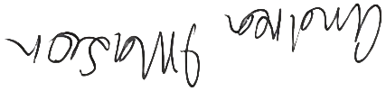

Andrea Mason
Chief Executive Officer
19 December 2025

NPYWC Annual Report 2023-24
NPYWC Strategic Plan 2024-2029

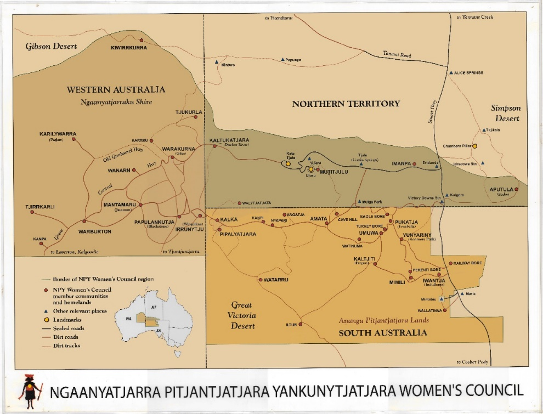
Annexure A:

Annexure B:
“This painting tells the story of how the NPY Women’s Council was started in 1980. I made a cassette tape and sent it around to all the communities for women to listen to. The black line going around the painting with the white marks is the cassette travelling around to all the women in communities. All the women listened to that cassette about the idea of starting up a Women’s Council. They sat down and talked together. Then we all came together at Kanpi to have our first meeting together. That is the big circle in the middle with all us women sitting around. This was the first time we came together, all us Pitjantjatjara, Ngaanyatjarra, Yankunytjatjara women.” - Mantatjara Wilson (deceased)

Brennan, Dechlan. “NT blocks UN prison inspectors amid accusation of hiding torture and abuse.” National Indigenous Times, 2025, https://nit.com.au/09-12-2025/21719/nt-blocks-un-prison-inspectors-amid-accusations-of-hiding-torture-and-abuse.
Torre, Giovanni. “UN Arbitrary detention experts slam Australia’s treatment of Indigenous people and children after being barred from NT and WA prisons.” National Indigenous Times, 2025, https://nit.com.au/13-12-2025/21795/un-arbitrary-detention-experts-slam-australias-treatment-of-indigenous-people-and-children-after-being-barred-from-nt-and-wa-prisons.
McGlade, Hannah, et al. International Convention on the Elimination of All Forms of Racial Discrimination – Early Warning and Urgent Action submission. www.hrlc.org.au/app/uploads/2025/04/United-Nations-CERD-complaint_youth-justice-in-Australia.pdf.
Arabena, Kerry. “First 1000 Days @ EAGxAustralia, Effective Altruism Australia 2016. https://Kerry+Arabena+first+1000+days
O’Connell, Ronan. “Cleveland Dodd coronial inquest findings call for Unit 18 to be shut down as a ‘matter of urgency’. National Indigenous Times, 2025, https://nit.com.au/08-12-2025/21686/cleveland-dodd-coronial-inquest-calls-for-unit-18-to-be-shut-down-findings.
Commonwealth of Australia. Royal Commission into the Protection and Detention of Children in the Northern Territory. 2020, www.royalcommission.gov.au/system/files/2020-09/report-overview.pdf.
Garrick, Matt., Hislop, Jack. “Nearly 400 Indigenous children and teens held in NT police watch houses over six-month period.” Australian Broadcasting Association, 2025, https://www.abc.net.au/news/2025-07-28/nt-indigenous-children-youths-watch-houses-data-investigation/105573004.
Brennan, Dechlan. “Ombudsman find inmates in ‘inhumane’ NT watch houses need to be removes as matter of urgency.” National Indigenous Times, 2025, https://nit.com.au/01-12-2025/21563/ombudsman-finds-inmates-in-inhumane-nt-watch-houses-need-to-be-removed-as-a-matter-of-urgency.
“Youth Detention Census.” Department of Corrections, 2025, https://corrections.nt.gov.au/youth-justice/youth-detention-census.
“Youth Justice in Australia 2023-24.” Australian Institute of Health and Welfare, 2025, www.aihw.gov.au/reports/youth-justice/youth-justice-in-australia-2023-24/contents/first-nations-young-people-under-supervision/youth-justice-supervision.
Unfinished Business – Royal Commission into Aboriginal Deaths in Custody. Aboriginal Legal Rights Movement, 2025, www.alrm.org.au/wp-content/uploads/2025/07/ALRM-Unfinished-Business-RCIADIC-FINAL-17.7.25.pdf.
Inspection of Banksia Hill Detention Centre and Unit 18 at Casuarina Prison (Part One). 148, Office of the Inspector of Custodial Services, 2025, www.oics.wa.gov.au/wp-content/uploads/2023/05/00.2-Clean-Copy-Inspection-Report-148-Banksia-Hill-Detention-Centre-and-Unit-18-at-Casuarina-Prison.pdf.
Baldy, Eileen., Cunneen, Chris. “Locking up kids damages their mental health and leads to more disadvantage. Is this what we want?” University of New South Wales, 2019, https://www.unsw.edu.au/newsroom/news/2019/06/locking-kids-damages-their-mental-health-and-leads-more-disadvantage.
Torre, Giovanni. “Leaked emails expose mental health crisis in youth prison, WA Law Society slams “unlawful” treatment of detainees. National Indigenous Times, 2023, https://nit.com.au/02-05-2023/5796/leaked-emails-expose-mental-health-crisis-WA.
Bower, Carol et al. “Fetal alcohol spectrum disorder and youth justice: a prevalence study among young people sentenced to detention in Western Australia.” BMJ open vol. 8,2 e019605. 13 Feb. 2018, doi:10.1136/bmjopen-2017-019605
“Royal Commission reaffirms urgent need for therapeutic approach to youth justice crisis- not another Government backstep”. Justice Reform Initiative, 2023, https://www.justicereforminitiative.org.au/media_release_royal_commission_reaffirms_urgent_need_for_therapeutic_approach_to_youth_justice_crisis_not_another_government_backstep
Gee, Graham, et al. “Aboriginal and Torres Strait Islander Social and Emotional Wellbeing.” Working Together: Aboriginal and Torres Strait Islander Mental Health and Wellbeing Principles and Practice, edited by Pat Dudgeon, Helen Milroy, and Roz Walker, 2nd ed., Commonwealth Government of Australia, 2014, pp. 55–58, www.telethonkids.org.au/globalassets/media/documents/aboriginal-health/working-together-second-edition/wt-part-1-chapt-4-final.pdf.
Justice Reform Initiative. “Imprisonment Is Failing Children and Communities: New Data Shows 85% of Kids Released from Detention Return Within a Year.” Justice Reform Initiative, 2025, https://www.justicereforminitiative.org.au/media_release_imprisonment_is_failing_children_and_communities_new_data_shows_85_of_kids_released_from_detention_return_within_a_year
Brennan, Dechlan. “Children in Detention Being Taken from Alice Springs to Darwin without Families Knowing, Parliament Told.” National Indigenous Times, 2025, https://nit.com.au/29-11-2025/21554/children-in-detention-being-taken-from-alice-springs-to-darwin-with-families-knowing-parliament-hears.

